INSTRUCTIONS FOR WRITING A PAPER FOR THE INTERNATIONAL CONFERENCE ON ALGEBRICAL AND
SYMBOLIC COMPUTATION

First A. Author¹*, Second B. Author² and Third C. Author²
1: Group or Department of First A. Author
School or Faculty
University
Postal address
e-mail: FirstAuthor@university.pt, web: http://www.group.pt

2: Group/Department of Second B. Author and Third C. Author
School or Faculty
University
Postal address
e-mail: {SecondAuthor, ThirdAuthor}@university.pt web: http://www.group.pt

Keywords: Instructions, international conference, algebraic, symbolic computation
Abstract This document gives you all the information and instructions you need to write your paper for inclusion in the Proceedings of the SYMCOMP 2021 – 5th International Conference on Numerical and Symbolic Computation Developments and Applications, which is taking place in Évora - Portugal at the 25 and 26 March 2021. Papers must be written in English, using LaTeX or MS-Word. The first page must contain: the title of the paper, authors‘ names and institutions, keywords and abstract. This page will be used for the book of abstracts and must not exceed one page. The instructions, plus sample files for LaTeX and MS-Word can be found in the Authors‘ Area on the conference website http://symcomp2021.isel.pt/ or http://www.symcomp2021.uevora.pt/.

1. INTRODUCTION
Abstracts proposals should not exceed 1500 words, and cannot have tables and figures. Their submission is made via conference website, until January, 31st, 2021.
The Proceedings, including text and figures, will be published electronically in Portable Document Format (pdf). Accepted papers should be submitted via the conference website, before March, 12th, 2021. Papers must follow the LaTeX or Word format shown in the samples on the “Instructions for authors” page. Papers must be converted into Portable Document Format (pdf) prior to sending. The organisers cannot commit to including any article in the Proceedings that is received after the stipulated deadline. At least one author must be registered and have paid the requisite fee by March, 12th, 2021 for the article to be included in the conference programme. A book of abstracts containing the basic information about each article will be published in addition to the Proceedings.

2. GENERAL SPECIFICATIONS
The paper must be written in English. The print area must be centred on each page and should cover an area of 16 x 21 cm. The article and its figures, tables and references must be at least 4 pages and no more than 20 pages long. The file may not exceed 4 Mb.

3. TITLE, AUTHORS, INSTITUTION, KEYWORDS
The first page must contain the title, author(s) and relevant institution(s), keywords and abstract. The introduction must start on the second page and follow the format of this file.

3.1. Paper title
The title must be in Times New Roman, 14 pt font, bold, upper case and centred. If the title occupies more than one line, the line spacing should be single.

3.2. Authors
Authors’ names must be given in full (not initials), i.e. given names and surname (see beginning of this document). The names must be in Times New Roman, 12 pt font, bold, and 12 pt below the title. If the MS-Word template is used, a header with the authors’ names must be included.

3.3. Institution
Details of the authors’ institution(s) must be in Times New Roman, 11 (10.95) pt, 12 pt below the list of authors. The line spacing between the institutions should be 12 pt.

3.4. Keywords
No more than six keywords are allowed. They should be aligned left and in Times New Roman 12 pt. The first line must start with the word Keywords, in bold. The line spacing between the institutions and keywords should be 12 pt.

3.5. Abstract (in the body of the paper)
The body of the article must contain an abstract thereof, written in Times New Roman, 12 pt, italics. The word ‘Abstract’ must be in bold and not in italics at the start of the first line. The Abstract text must be justified, in italics and have a 12 pt space between it and the keywords, as shown on the first page of these instructions.
The abstract must not, in any circumstances, extend beyond the space available on the first page. This first page, with the paper’s title, its authors names and institutions, keywords and abstract, will be used for the book of abstracts.

4. HEADINGS

4.1. Main headings
The main headings must be aligned left, Times New Roman 12 pt font, bold, upper case. Line spacing must be 12 pt before and 6 pt after each main heading.

4.2. Subheadings
The subheadings must be aligned left, Times New Roman 12 pt font, bold, initial capital for fist word. Line spacing must be 12 pt before and 6 pt after each subheading.

5. HEADERS
As shown in these instructions, the first page has one header and the header of the remaining pages consists of the authors’ names. The editors will add these headers if they are omitted. But the authors are kindly asked to include them, formatted per these instructions. Note that the headers are outside the print area (see Figure 1).

6. Text
The main body text shall be Times New Roman, 12 pt, single spaced, justified and in a single column. No extra spacing is required between paragraphs.
7. PAGE NUMBERING
Articles will be locatable by author’s name, title or topic. Page numbering is therefore not allowed.

8. FIGURES
All figures should be numbered consecutively and be identified by their caption. Figure captions must be Times New Roman, 10 pt using both upper and lower case, and centred.
There must be a 6 pt space between each figure and its caption, and a 12 pt space between the body text and the upper border of the figure and the last line of the caption and the next section of the text.
Figures may be within the body of the text or at the end of the article.

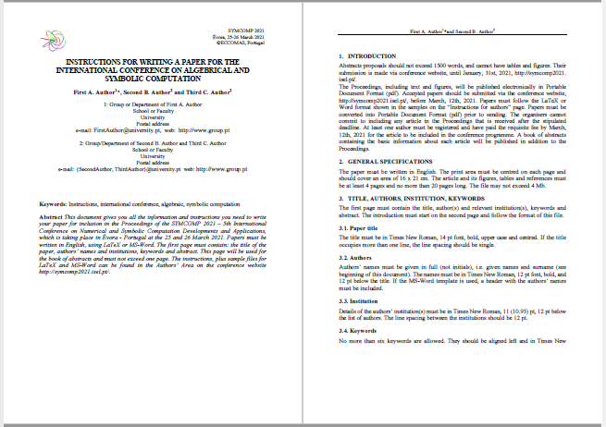
Figura 1. Layout of first page and subsequent pages.

9. EQUATIONS
Equations must be numbered in Arabic numerals, enclosed in brackets. Equations must be centred and separated from the text above and below by a 6 pt space.
The example below is a single-line equation:

(1)

The example below is a group of aligned equations:

(2)
10. TABLES
All tables should be numbered consecutively and be identified by their caption. Table captions must be Times New Roman, 10 pt using both upper and lower case, and centred.

C11 | C12 | C13
C21 | C22 | C23
C31 | C32 | C33
C41 | C42 | C43
C51 | C52 | C53
Table 1. Example of table layout
There must be a 6 pt space between each table and its caption, and a 12 pt space between the body text and the upper border of the figure and the last line of the caption and the next section of the text.

11. REFERENCES
References within the text must be cited using numbers enclosed by square brackets 0[2][3]. At the end of the text references must be in numerical order, as shown at the end of these instructions.

12. CONCLUSIONS
The article must have a section containing some final considerations and the main conclusions drawn from the work described that will be presented at the conference.
- Abstracts proposals and papers should be submitted electronically via the conference
- website, http://symcomp2021.isel.pt/ or http://www.symcomp2021.uevora.pt/.
- Papers must be written in accordance with the format of the files available on the Instructions for Authors section.
- Papers must be converted into Portable Document Format (pdf) prior to submission.
- Papers must be sent by March, 12th, 2021.
- The organisers cannot undertake to include articles received after that date.
- At least one author must be registered and have paid the requisite fee by March, 12th, 2021 for the article to be included in the conference programme.

references
  - Hong, H.,Jakuš, D. ”Testing Positiveness of Polynomials”, Journal of Automated Reasoning , Springer Netherlands Vol. 21(1) , pp. 23-38, 1998.
  - Kunkle, D.,”Roomy: a system for space limited computations”, PASCO’10 Proceedings of the 4th International Workshop on Parallel and Symbolic Computation, Ed. Marc Moreno Maza and Jean-Louis Roch, Grenoble - France, pp. 22-25 , 2010.
  - Reddy, J.N., Mechanics of Laminated Composite Plates. Theory and Analysis, CRC Press, New York, 1997

